**Chemistry: 12. Elements, Compounds and Mixtures**

***Please remember to photocopy 4 pages onto one sheet by going A3→A4 and using back to back on the photocopier***

**Syllabus**

**OC3** Understand what an element is and recall that all known elements are listed in the Periodic Table; understand what a compound is and what a mixture is; recall that when elements combine to form compounds they may lose their individual properties

**OC4** Examine a variety of substances and classify these as elements or compounds (using the Periodic Table as a reference)

**OC12** Compare the properties of the simple compounds H2O, CO2, MgO and FeS to those of the constituent elements

**OC13** Compare mixtures and compounds made from the same constituents, and understand that an alloy is a mixture

**Student Notes**

We saw in a previous chapter (States of Matter) that everything is made of atoms.

We also saw that there are many different types of atom (over 100 in fact), and some substances are made from just one type of atom, while other substances are made from combinations of different types of atom.

**Elements**

If a substance is composed of just one type of atom then that substance is known as an *element*.

Copper wire is made up of only copper atoms; a gold ring is composed of only gold atoms.

We say that copper and gold are *elements*

We have already seen that the different types of elements are arranged in terms of their atomic number (the number of protons in the nucleus) in a table called the *Periodic Table of elements.*

**Elements are substances which are made up of only one type of atom**

**Compounds**

**A compound is formed when two or more atoms *of different elements* combine together chemically**

An example of a compound is table-salt.

It is a compound because it is made up of two different types of atom – in this case sodium and chlorine. The chemical name for table-salt is NaCl.

The interesting thing is that both sodium and chlorine can be fatal if ingested (swallowed) on their own, but when the two go together to form table-salt the result is perfectly safe (once you don’t eat too much!).

We can summarise this as follows:

**When elements combine to form compounds they often lose their individual properties**

**Other examples of compounds and their constituent elements**

|  |  |  |  |
| --- | --- | --- | --- |
| **Compound** | **Symbol** | **State of matter**  **(at room temp)** | **Elements in the compound**  **(and state at room temp)** |
| Water | H2O | liquid | Hydrogen (gas)  oxygen (gas) |
| Carbon dioxide | CO2 | gas | Carbon (solid)  oxygen (gas) |
| Magnesium oxide | MgO | solid | Magnesium (solid)  oxygen (gas) |
| Iron sulphide | FeS | solid | Iron (solid)  Sulphur (solid) |

**Molecules**

Some atoms form a very strong attachment (‘bond’) to another atom or atoms and as a result they always go around in groups of two or more atoms. We call these groups of atoms ‘molecules’.

It is very hard to break these ‘bonds’ and we say that in this case the atoms are ‘chemically combined’. We will look at this bonding in detail in another chapter.

**A molecule is made up of two or more atoms chemically combined**

Also

**A molecule is the smallest part of an *element* or *compound* that can exist on its own**

Basically a molecule is like a very small group of atoms that go around together (they are still too small to see).

Examples:

For the element *oxygen* the atoms go around in pairs.

These are then called oxygen *molecules* and that is why oxygen is often represented as O2.

For the compound *water* the atoms go around in ‘gangs’ consisting of two hydrogen atoms and one oxygen atom. These ‘gangs’ are called water molecules and that is why water is often represented as H2O.

**My head hurts; what’s the difference between a compound and a molecule?**

All compounds are molecules, but not all molecules are compounds (e.g. H2 is a molecule because it is composed of two atoms chemically combined, but because they are both the same element (hydrogen) the molecule is not a compound).

O2 is a molecule but it is not a compound for the same reason.

H2O is both a molecule (because it is composed of two atoms) and it is also a molecule (because there are two different types of element involved; hydrogen and oxygen).

Remember when we said that atoms are so small that you can’t see them?

Well molecules are made up of small groups of atoms so you won’t be able to see them either.

**Mixtures**

If a substance is made up of different components but they are just mingled together rather than combined at an atomic level then we call this a mixture.

**A mixture contains two or more different substances mingled together but not chemically combined**

**A mixture is a combination of elements in an unfixed ratio**

Mixtures can be (fairly) easily separated, whereas compounds cannot be easily separated.

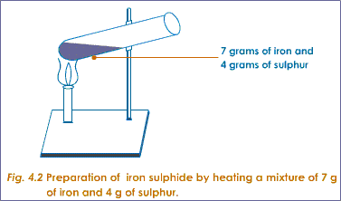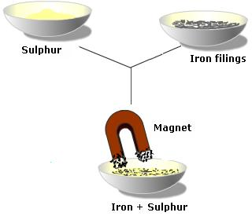

If you pour sulphur power over iron filings and mix them together you get a mixture, and to separate them simply use a magnet which will attract the iron filings and leave the sulphur powder behind.

However if you heated the mixture to a very high temperature their chemical compositions will change and the two elements will ‘bond’ together chemically to become a new substance called iron sulphide.

This cannot now be separated and the result is called a compound.

**Summary**

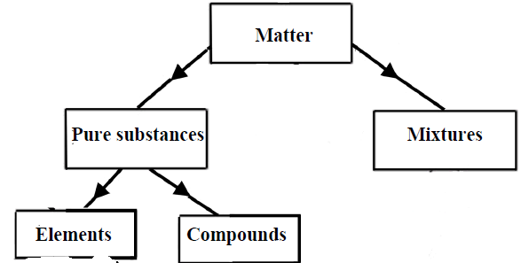

Another way of thinking about a compound is that it is a mixture of elements in a fixed ratio.

Wanna talk about Sodium?

Na

Nitric Oxide?

NO

Oxygen Magnesium Phosphorus Iodine Sulfur or Flourine? OMg PISS OFF ...

Potassium?

K

**Exam Questions**

|  |
| --- |
| Table Salt  Carbon  Air |

1. [2006 OL]

Identify one mixture and one compound from the list on the right.

1. [2011 OL]

|  |
| --- |
| Water Nitrogen |

Identify the element and the compound from the list on the right.

1. [2012 OL]

|  |
| --- |
| Ink |
| Carbon Dioxide |
| Iron |

Substances can be classed as elements, compounds and mixtures.

1. Which of these substances is a compound?
2. Which of these substances is a mixture?
3. Which of these substances is an element?
4. [2009 OL]

|  |
| --- |
| Element  Compound |

Complete the following sentence using the words from the list on the right.

Water is an example of a _______________ and hydrogen is an ________________ found in water.

1. [2007 OL]

Write the name of each of the two elements present in water.

|  |
| --- |
| Aluminium |
| Copper |

1. [2009 OL]

What is the symbol of each of the metallic elements on the right?

1. [2011][2007]

What is an element?

1. [2011]

What is a molecule?

1. [2011][2007]

What is a compound?

1. [2010]

Give two different propertiesof the element magnesium compared to the compound magnesium oxide.

1. [2011]

Matter is the ‘stuff’ that all things are made of, including us.

The diagram shows how some types of matter are classified.

The diagram is not complete.

Elements can be divided into two sub-groups.  
Name these two sub-groups.

1. How could you use lego to explain elements, molecules, compounds and mixtures?

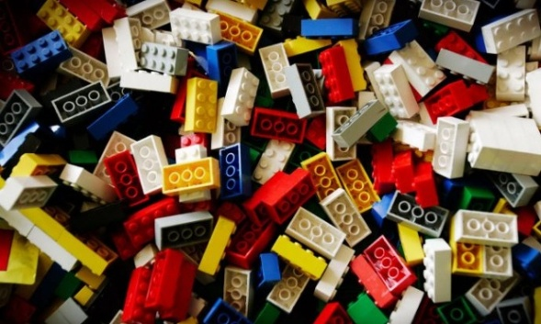

**Exam Solutions**

1. The mixture is air and the compound is table salt.
2. The element is nitrogen and the compound is water.
3. Carbon dioxide
4. Ink
5. Iron
6. Water is an example of a compound and hydrogen is an element found in water.
7. Hydrogen and oxygen
8. Al
9. Cu
10. Element: An element cannot be broken down into simpler substances.
11. A molecule consists of two or more atoms chemically combined / smallest particle of a substance /smallest particle that can exist on its own
12. Compound: A compound is composed of two or more elements chemically combined.
13. Magnesium: is ‘silver’/ metal/ shines/ bends/ ductile/ malleable/ reacts with acids releasing hydrogen/ conducts electricity/ conducts heat/ burns in air (Oxygen)…

Magnesium Oxide: white/ powder/ base/ does not burn/ does not conduct electricity/ does not conduct heat…

1. Metals, e.g. Copper, Iron, Zinc etc

Non-metals, e.g. Sulphur, Nitrogen, Phosphorus etc.

**Other Test Questions**

1. A student carried out an investigation comparing the properties of a mixture of iron and sulphur and the compound iron sulphide.

Name and explain a method that the student could use to separate the iron from the sulphur in the iron and sulphur mixture.

Method of separation:

Explanation:

Could the method of separation that you have suggested be used to separate the iron from the sulphur in the compound iron sulphide?

Explain your answer.

1. Complete the following table

|  |  |  |  |  |  |
| --- | --- | --- | --- | --- | --- |
|  | **Symbol / chemical formula** | **Element** | **Molecule** | **Compound** | **Mixture** |
| Hydrogen |  |  |  |  |  |
| Soil |  |  |  |  |  |
| Water | H2O |  |  |  |  |
| Vinegar |  |  |  |  |  |
| Carbon dioxide | CO2 |  |  |  |  |
| Aluminium |  |  |  |  |  |
| Alcohol |  |  |  |  |  |
| Magnesium oxide | MgO |  |  |  |  |
| Calcium |  |  |  |  |  |
| Lemonade |  |  |  |  |  |
| Iron sulphide | FeS |  |  |  |  |
| Mercury |  |  |  |  |  |
| Salt |  |  |  |  |  |
| Sugar |  |  |  |  |  |
| Ammonia |  |  |  |  |  |
| Milk |  |  |  |  |  |
|  |  |  |  |  |  |
| Water and alcohol |  |  |  |  |  |
| Salt water |  |  |  |  |  |
| Air trapped in soil |  |  |  |  |  |
| Our atmosphere |  |  |  |  |  |
| Oxygen dissolved in water |  |  |  |  |  |

How could you use lego to explain the difference between elements, compounds and mixtures?

